SIX MONTH INDUSTRIAL TRAINING
MID TERM REPORT
ON
AI STUDY NOTES GENERATOR

MASTER OF COMPUTER APPLICATION



SESSION: 2025-2026

SUBMITTED TO:

SUBMITTED BY:

DEPARTMENT OF COMPUTER APPLICATION
GOVT PG COLLEGE UNA (H.P)

INDEX

TITLE

AI STUDY NOTES GENERATOR

INTRODUCTION TO PROJECT

The project “AI study Notes Generator “ is an intelligent system
Designed to automatically generate concise , structured and easy –
To –understand study notes from large volume of educational content
Such as PDFs, text files, and documents. With the rapid growth of
digital learning material , students often face difficulty in revising
and extracting key points from lengthy resources. This project
provides a smart solution by leveraging Artificial Intelligence and
summarize and convert raw content into meaningful and convert
into meaning study notes.
The system focuses on reducing manual effort, saving time, and
improving learning efficiency by delivering topic-wise summarized
notes that can be used for quick revision and exam preparation.

1.2 Description of Project
AI Study Notes Generator accepts input in the form of PDF or text
Documents uploaded by the user. The content is process using NLP
Based text splitting and transform models to understand content
And generate high-quality summaries. The application user pre-
Trained transformer models such as BART and T5 for text
Summarization and text-to-text generation. The output is presented
In a clean and interactive user interface, making it user-friendly for
Students.
The system is capable of handling large documents by breaking them
Into smaller chunks and generating coherent notes for each section.

1.3 Objective of Project
The main objective of the project are:
1: To develop an AI-based system for automatic generation of study notes.
2: To reduce time and effort required for manual note-making.
3: To provide accurate and concise summaries from large documents.
4: To improve learning productivity and revision efficiency
For students.
5:To build an easy-to-use web interface for document upload and Note generation.
CHAPTER 2

REQUIREMENT ANALYSIS AND LITERATURE SURVEY

2.1: Existing Projects of Similar Characteristics
Several existing system focus on text summarization and document
Processing . Tools like online summarization and note-making
Applications provide basic summaries but lack contextual
Understanding and customization . Most existing solution do not
Efficiently handle large academic documents or provide structured
Study-oriented notes.

2.2 Need to Develop this project
Students and learners face challenges in managing vast amount of
study material. Manual note-making is time-consuming and often
Inefficient .There is a strong need for an automated system that
Can quickly generate meaningful notes while preserving important
Concepts. This project addresses this gap by using advanced AI
Models capable of understanding context and generating
High-quality summaries.

2.3 Course of Action
1: Requirement analysis and problem understanding.
2: Selection of appropriate NLP models and tools.
3: Designing system architecture.
4: Implementation of document loading and preprocessing.
5: Integration of summarization models.
6: Development of user interface.
7: Testing and performance evaluation.

2.4 :Literature Survey
The literature survey includes research paper and articles related
To text summarization , transformer-based models and NLP
techniques . Studies on BART and T5 models demonstrate their
effectiveness in abstractive summarization. Research on document
chunking and recursive text splitting techniques also supports the
approach used in this project.

CHAPTER -3
PLANNING OF THE PROJECT

3.1 Objectives of project
The planned objective of the project are:
1: To design an efficient document summarization pipeline.
2: To integrate transformer-based NLP models
3: To ensure scalability for large documents.
4: To provide accurate and structured study notes.
5: To deploy a functional web-based application.

3.2 Planned Steps To Achieve Above Objectives

Step 1: Data collection and document input handling.
Step 2: Text preprocessing and chunking.
Step 3: Applying NLP models for summarization.
Step 4: Generating structure study notes.
Step 5: Designing and implementing user interface.
Step 6: Testing and optimization.

CHAPTER – 4
HARWARE AND SOFTWARE REQUIREMENTS

4.1 Hardware Requirements

. Processor: Intel i5 or Higher
. RAM : Minimum 8 GB
. Storage : 256 GB or higher
. Internet : Connection for model loading.

4.2 Software Requirements

. Operating System : Windows / Linux
. Programming language: Python

4.3 Tools Used For Development Of Project

. Python
. Langchain
. HuggingFace Transformers
. BART (Text Summaization model)
. T5 (text-to-text generation model)
. Recursivecharacter textsplitter
. Prompt Templates (langchain)
. Streamlit
. PyPDFLoader / Textloader
. HuggingFace Tokenizers

4.4 Techniques Used For Development of Project
The project uses NLP techniques such as abstractive text
Summarization , transformer-based deep learning models,
Tokenization, and recursive text splitting to handle large
Documents efficiently.

CHAPTER-5

DESIGN OF THE PROJECT

5.1 Flow Chart Diagram

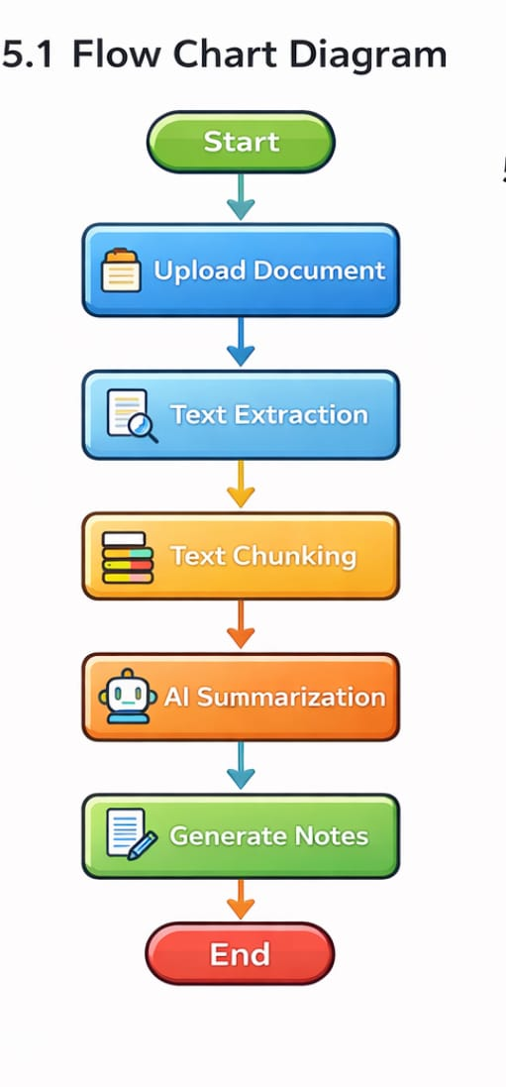

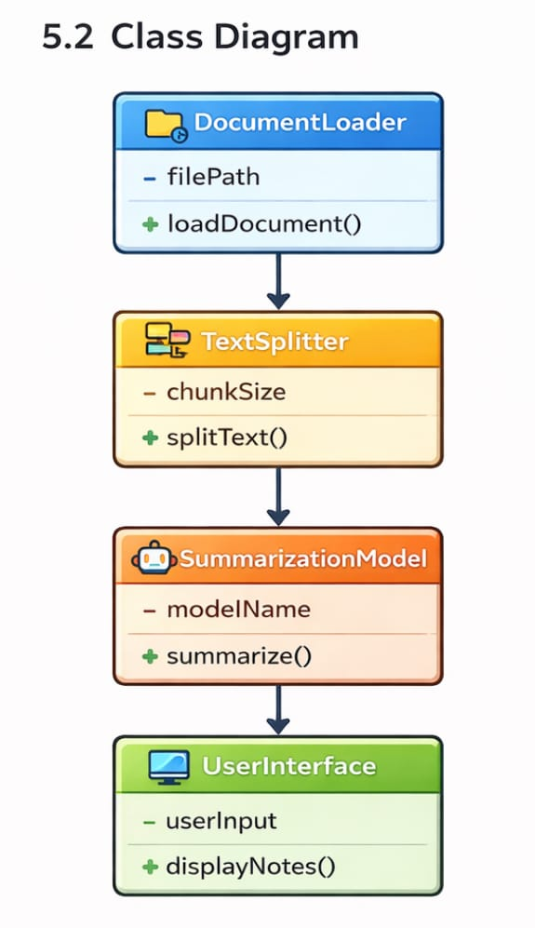

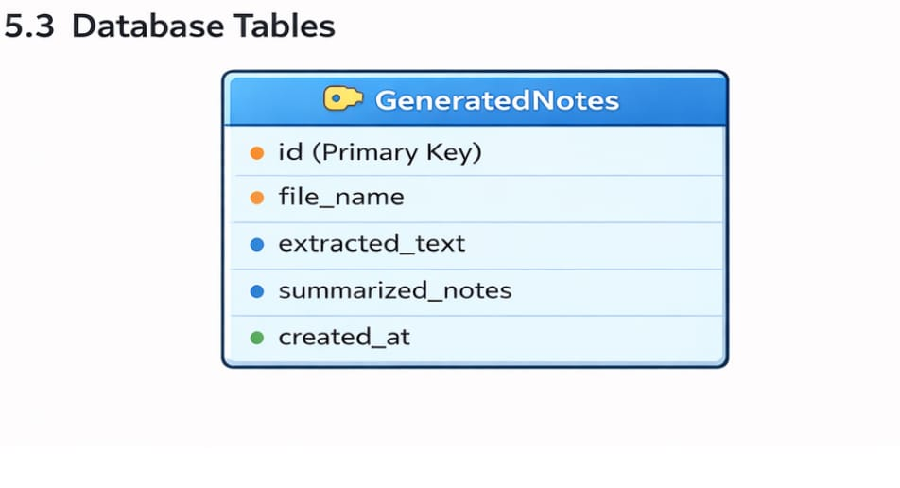
CHAPTER-6

REFERENCES

REFERENCES 1. Vaswani, A., et al. (2017). Attention Is All You Need. NeurIPS. https://arxiv.org/abs/1706.03762
2. HuggingFace Transformers Documentation: https://huggingface.co/docs/transformers
3. LangChain Official Documentation: https://docs.langchain.com/
4. HuggingFace Summarization Guide: https://huggingface.co/docs/transformers/tasks/summarization
5 . Research Articles on Text Summarization (arXiv): https://arxiv.org/

